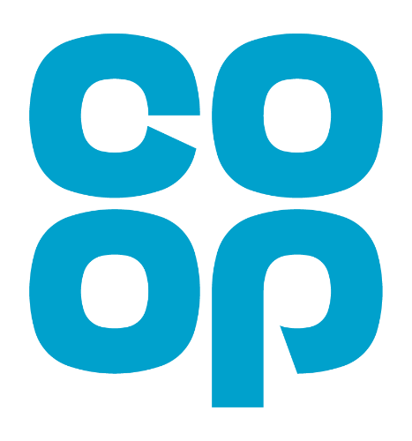

The Co-op Local Community Fund: Empowering Stronger Together Across Ringwood and Fordingbridge (STARF)

How Your Shopping Can Make a Difference

The Co-op Local Community Fund is an initiative designed to support local causes and community projects that make a real difference to the lives of people in their neighbourhoods and, in our case, Ringwood and Fordingbridge.

By shopping at Co-op, members can help direct funds to charities and groups that are working tirelessly to improve their communities.

## How It Works

We’re part of the @coopUK Local Community Fund. Co-op Members can help raise funds for our project by choosing Stronger Together Across Ringwood & Fordingbridge as your cause at <https://membership.coop.co.uk/causes/87257>.

Each year, Co-op members are invited to choose a local cause that they want to support. These causes can range from youth clubs, food banks, educational programs, to environmental projects and beyond. The funds are then distributed based on the spending patterns of members who have chosen that particular cause. The more members who select a cause, and the more they spend, the bigger the share of the fund that cause receives.

# The Benefits for STARF

STARF stands to gain significantly and has already received a donation of £500 from Co-op. Here are some specific ways in which this funding can benefit, for instance, with additional funds, STARF can enhance the services we already offer to our beneficiaries, such as providing essential support to families in emergency financial crisis, employing a School Hardship Worker to assist families in crisis, reviewing their finances and accessing Government and other charitable aid, employing mental health practitioners, in local schools to support young minds and reverse harmful behaviour patterns

Being a part of the Co-op Local Community Fund also raises our profile within the community. It connects us with a network of Co-op members who are invested in supporting local causes.

Ultimately, the most important benefit is the positive impact on the lives of our beneficiaries. With the support of the Co-op Local Community Fund, we can empower individuals and families, providing them with the tools and opportunities they need to lead better lives. Whether through educational programs, health initiatives, or social services, the funding helps us make a tangible difference.

# How You Can Help

To maximize the benefits for STARF, we encourage everyone to become a Co-op member and select our cause. Here's how you can get involved:

* Become a Co-op Member: Sign up to be a member of the Co-op. It's easy and comes with numerous benefits, including the ability to earn rewards on your purchases.
* Shop at Co-op: Make your everyday shopping count by choosing Co-op branded products and services. A portion of your spending will go into the Local Community Fund.
* Choose STARF: When selecting a cause to support, choose our charity. This ensures that the funds generated by your purchases are directed towards our projects and initiatives.
* Spread the Word: Encourage friends, family, and colleagues to join the Co-op and support our charity. The more people who select our cause, the more funding we can secure.

So many people have already benefited from the support STARF has been able to provide and we would like to ensure this continues.

Thank you for your support and commitment to our causes. Let’s work together to build a brighter future for Ringwood and Fordingbridge.