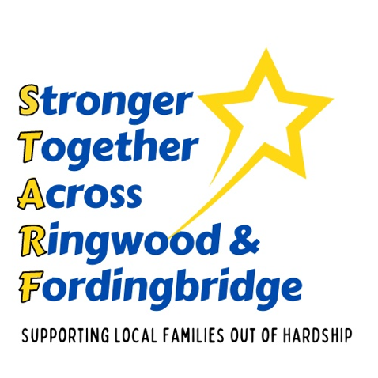
Ideas for Fun Activities

- Children write a list of things to do in the holidays
- Make an obstacle course in the garden / park
- Draw with chalk or water
- Keep a summer journal – notes and drawings
- Play in the sand at Moyles Court or the beach
- Have a picnic / teddy bears’ picnic
- Make fruit kebabs
- Roast marshmallows on a fire
- Repair something
- Try geocashing
- Lie out under the stars at night
- Camp in the garden / lounge
- Make a den in the garden / house
- Race paper boats across a tray of water
- Different people tell a story one line at a time
- Make sock monkeys / bunnies
- Put on a puppet show
- Make friendship bracelets
- Go on a scavenger hunt
- Have a board game afternoon
- Have a water fight
- Fingerprint the whole family and compare them
- Make a family picture of foot or handprints
- Read from a book every day
- Play 40:40 or hide and seek
- Make slime
- Explore the New Forest or Poulner Lakes
- Float a stick down the river
- Have a standing long jump comp on sand
- Look for shapes in the clouds
- Put on a talent show
- Make some dominos and play
- Try connect 4 on paper
- Perform a random act of kindness
- Film a music video
- Find 10 different types of tree near your house
- Paint or draw a picture
- Make a collage
- Read to a sibling / adult / grandparent
- Make a wordsearch
- Try a new fruit of vegetable
- Tell a joke at dinnertime
- Bake a cake / biscuits
- Play charades
- Visit an elderly relative of neighbour
- Make a marble maze
- Examine a rockpool
- Visit a library
- Make popsicles
- See how many times you can fold a piece of paper
- Make something out of cereal boxes

