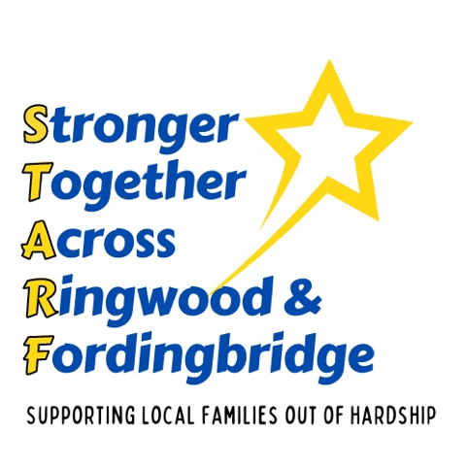
Places to Visit

Avon Heath Country Park, St Leonards, BH24 2DH
Woodland Walks, Play Area, Picnic Area, Café

Avon Valley Community Matters
Run a family days (lunch, activities, craft etc.)
https://www.avcmatters.org/holiday-activities

Blashford Lakes, Ellingham Drove, Ringwood, BH24 3PJ
Nature Reserve and Trails

Bolderwood Deer Santuary, SO43 7GE
Viewing platform to spot deer – Deer fed daily by keeper.
Close to main Bolderwood Car Park – Picnic Area, Ice Cream Van

Carvers Recreation Park, Ringwood, BH24 1JD
Skate Park, Playground, Café, Summer Activities. They also offer free child and young person meals for discount card holders (see Things To Eat page)
There are a range of amazing free events over the summer. See their facebook page: https://www.facebook.com/carversclubhouse/?locale=en_GB

Castleman Trailway
Cycle from Ringwood to West Moors/Moors Valley

Gullivers Farm and Café, Station Road, West Moors, Ferndown, BH22 0JG
Animals, Play Area, Orchard Gardens, Ride n Toys, Nature Trail
Hockey’s Farm
Go and see their animals for free.

Hobbycraft Ferndown
Check on their website as they offer craft workshops for as little as £3/£4
Linford Bottom, Ringwood
Stream, Woodland Walks, Picnic Area, Ice Cream Van

Moors Valley Country Park, Ashley Heath, BH24 2GT
Loads to do Woodland Walks, Wooden Climbing Structures, Café, Train, Lake, Picnic Areas, Summer Activities
Car park can be expensive!

Mudeford Quay, Christchurch, BH23 4AB
Crabbing, Playground, Cafes, Ferry over to Hengistbury Head

Nicks Farm Valley Road, Bournemouth, BH8 0EB
Only £5 per person
Petting Farm, Feed the goats, Snack Shop
They offer help for children and young people with special needs, call ahead on 07412275255 or email nicksfarm2022@gmail.com

Potterne Park, Verwood, BH21 6RS
Skate Park, Playground, Café, Picnic

Ringwood Health & Leisure Centre, BH24 1PX
Fun Swims & HAF funded holiday camps

Ringwood Library 19th August 2024
Fun Drama with Forest Forge. Free places book here;
https://forms.office.com/pages/responsepage.aspx?id=tdiBPwfuF0yGnB20OQGNm5Z6u58NE2JHjFhDgfIY141URElHVUwwSk1SRlNLQjRVVU80SjRQMjRCMy4u
'Crazy Cartoons and Incredible Illustrations' HAF session on Monday 22nd July. This event is suitable for children aged 4-11 and who receive free school meals as part of pupil premium or are supported under an SEN/EHCP.
Free places book here:
https://forms.office.com/pages/responsepage.aspx?id=tdiBPwfuF0yGnB20OQGNm5Z6u58NE2JHjFhDgfIY141UNU45MENOQUtEMFVGSUY1QTQySU9SMEY4MC4u

Power Up Children’s clubs –
Poulner Baptist Chapel – Run a range of fun activities in School Holidays
Karl Haywood - 01425 473388
Some free places are available

RACE – Run a variety of children and adult activities –
enter a donation of £0 to obtain a free place if you have
a discount card issued by the school

Sandpits – Moyles Court, BH24 3LZ
A great fun day out sliding down the sandpits and playing in the nearby stream. Ice cream van. Children and Young People should always be supervised.

​The Branch
The Branch are connecting with the Community Garden & Fordingbridge Green living / Green gram to provide free activities once you have finished your free breakfast. This can be anything from rock painting, seed planting at the Community Garden & on the 3rd week, families can register for a free bag of ingredients to make their own scones at home from the Green Gram.
(See Places to Eat for free breakfast days.
https://newlifecommunitychurch.co.uk/connect/the-branch/

