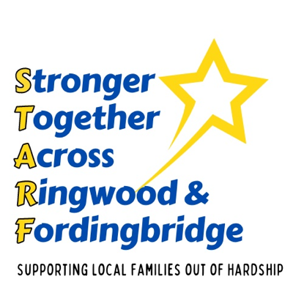
Places to Eat
FREE FOOD:
Kids Eat Free - Website giving information on national kids eat free schemes.
Kids eat free

Belinda’s Bakery Poulner & Fordingbridge
Offer a Free Child or Young Persons lunchbox (Sandwich, crisps and a fruit drink)
https://www.belindas-bakery.co.uk

Carvers Clubhouse Café
Offer a Free Child or Young Person Lunchbox
https://carversclubhouse.co.uk

Foodbank Ringwood
The Wesley Centre, Christchurch Road, BH24 1DN
Monday, Wednesday & Friday 9.30 – 12.30
Foodbank Fordingbridge
Fordingbridge United Reform Church, 41 Salisbury Street. SP6 1AB
Monday, Wednesday & Friday 12.30 – 2.30
www.ringwood.foodbank.org.uk

Framptons Ringwood
A child eats free with a paying adult
www.framptonsbar.co.uk

The Branch High Street Fordingbridge
Suppling toast, cereals, fruit, yogurt, juice, teas & coffees. Running over 3 weeks this summer 23rd, 24th, 30th & 31st July & 6th & 7th August (Tuesdays & Wednesdays).
The Branch are also connecting with the Community Garden & Fordingbridge Green living / Green gram to provide free activities that families can go to after breakfast. This can be anything from rock painting, seed planting at the Community Garden & on the 3rd week, families can register for a free bag of ingredients to make their own scones at home from the Green Gram.
https://newlifecommunitychurch.co.uk/connect/the-branch/

GOOD VALUE FOOD:
Fareshare Mobile Larder
Ringwood Health & Leisure Centre, Car Park
Friday: 1.30 – 3pm
All Saints Church, Three Legged Cross
Monday: Between 9.30am and 11am
https://fish.hants.gov.uk/kb5/hampshire/directory/service.page?id=Yr5Lt2B54lA
https://www.helpandkindness.co.uk/service/4833/The-Three-Legged-Cross-Fareshare-Pop-Up-Larder

Ringwood Community Fridge
The Library, Greyfriars
https://www.facebook.com/groups/523555478827824/?locale=en_GB

Too Good To go
A popular phone app that helps fight food waste. It links you with nearby restaurants, cafes, bakeries and shops who have leftover, reasonably priced food at the end of the day
www.toogoodtogo.com/en-gb/user

Poulner Fish & Chips
10% discount on a child’s meal
https://www.facebook.com/Poulnerfishandchips/?locale=en_GB

Jaqueline’s Tea Room
10% off all children’s meals
https://www.facebook.com/p/Jacquelines-Tea-Rooms-Gifts-Ringwood-Hampshire-100063575020083/

