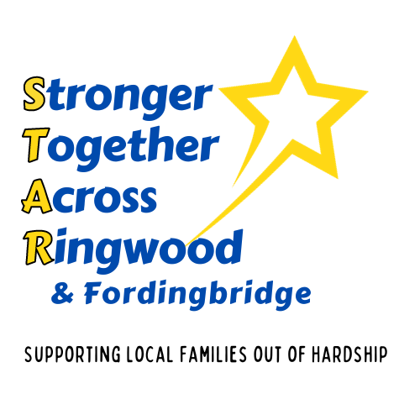
Sponsorship Packages - Help STAR by donating annually.

We have a range of annual donation packages to suit every pocket. Check with your accountant as Tax Relief on donations is available to many businesses.
 | Bronze | Silver | Gold
Package | Friend of STAR | Partner of STAR | Sponsor of STAR
Donation per year | Up to £499 | £500 - £4999 | £5000
Termly Newsletter
Invitation to STAR annual meeting
Social Media Posts |  | 1 per quarter | 1 per month
Listed on our Website
Logo and Hyperlink on our Website
Use of our logo on your website
Presentation Cheque with publicity
Framed Certificate

Become a STAR by completing the following sign-up form:
Business Name:
Contact Name:
Email: Phone Number:
Type of Package: Bronze Silver Gold
Amount of annual donation: £
This data will be maintained on a databased used only for STAR charity
I am happy to receive termly STAR newsletters and correspondence by email
THANK YOU SO MUCH FOR ALL YOU ARE DOING
Ways to Support STAR

STAR is all about bringing the business community together to support families in crisis in the Ringwood & Fordingbridge area.
Can you or your business work with us to deliver the help families need right now?

Be creative – there are so many ways you can help!
- Add an option of a donation to STAR charity on your invoices.
- Go BIG and match those donations.
- Offer incentives for introductions to your business and donate when you have signed the contract. We’ll happily post your offers on our social media.
- Bring your team together and run a charity event on behalf of STAR – it can be anything from Three Peaks Challenge to a Cake Sale.
- Sponsor an event for STAR and get publicity for your business.
- Have a collection box in your shop.
- Volunteer to give STAR a day or two of your time.
- Promote STAR to other businesses and help us to increase our following.
- Donate business services to STAR.

Donate:
- £60 and pay for a counselling session for a child or young person in need,
- £600 will pay for a full series of counselling sessions for one child or young person in need.
- £4K to raise the final sum needed for the 1st year of our School Hardship Worker
- £18K to complete our funding for a Counselling Team for a year.
- £30K will put a Debt Coach and a team of Debt Befrienders in our schools for a whole year.
Can you help?
Email: help@starf.uk with your ideas.

THANK YOU SO MUCH FOR ALL YOU ARE DOING

